Office 365 Student Guidelines and Expectations

Office 365 Application Info:

Office 365 is Word, Excel and PowerPoint, only it is cloud-based. That means you can access your applications and files from any device connected to the Internet via a browser. You have almost an unlimited amount of storage with your OneDrive account, so don’t worry about saving to hard drives or flash drives ever again! Office 365 is made available for you by Volusia County Schools. The account will be yours until the December after you graduate or leave the district.

Office 365 Social Info:

In addition to allowing you to create and store Word, Excel and PowerPoint documents in OneDrive, Office 365 has a social component. You can share and collaborate with multiple people on documents for group projects. You can blog for class or an assignment, post on a newsfeed and share comments with your class. There is an e-mail associated with the account, but it is limited to sending e-mails to people within the district. It’s to be used to turn in work to teachers or share documents with peers, not really for 2 way communication. Office 365 communication is connected to school. This is not a personal social networking site and what you say and do must follow appropriate school guidelines.

General Guidelines for Use:

- You can access Office 365 several ways:
School: sign into VPortal
Home: 1. Go to Volusia County Schools homepage: http://myvolusiaschools.org and log in through your VPortal account, 2. use your device’s browser (Safari, Chrome, Firefox) and use the “Edit Online App” feature at the top left of the document or 3. download the Office for Mobile app (iPhones, Android, and Windows or the OneDrive for Business all (iPads).
- Be sure to log out of your COMPUTER, (don’t just x out of the browser) when finished using Office 365.
- Think of Office 365 as a classroom. Do not say or do anything that you wouldn’t do in a classroom.
- Practice digital etiquette. Avoid using ALL CAPS when typing and use emoticons to show expression sparingly. Sign your name after every post or email message.
- If you are using the comments feature, make sure your comments are on-topic with the assignment. Be very specific in your comments and questions.
- Check spelling and grammar in all communications with peers and teachers.
- Use spaces between paragraphs if you have a lot of text.
- Be positive and considerate of other’s feelings. Report inappropriate or bullying behavior to a teacher or school administrator immediately. Know that behavior on Office 365 is a part of district record and incidents must be promptly reported for action to be taken.

Sharing Guidelines:

Each document has the option to “share.” From OneDrive, select the checkbox next to the document and click the “…” icon. Your document will open in a box with the share option listed at the bottom. When you select the share option, you will enter the name of the person you would like to share with, along with a description. You have the option of choosing “Can Edit” if you would like the person receiving the document to be able to edit it, or you can choose “Can View” if you only want them to be able to read the document. Be careful about who you give these rights to!

- Only use the “Can Edit” feature if you want someone to be able to make changes to (or possibly delete) your document. If someone shares a document with you, you should NOT share that document with someone else. It is up to the owner of the document to determine how their document will be shared.
- If you want others to be able to view your document without making changes, give direct “view” rights by selecting their name from the directory OR you can use “get link” for “can view.”
- When you are sharing your document with your teacher, please be sure to check or uncheck the “send email notification” box depending upon what the teacher has requested. This is found under the “show options” link.
- You can also share your work directly from the application you are working in.

A Note about Password Security – Please read carefully!!

If you have shared your alpha code with others, you will want to change your password inside the student VPortal to make sure your account is secure BEFORE you use Office 365. This will change your password for Office 365, Gradebook and any other school applications linked to your account. You can access VPortal on the Volusia County School website under the student tab or go to http://vportal.volusia.k12.fl.us/. The first time you login to VPortal it will ask you to answer some security questions. This is VERY important because it will allow you to reset your password if you ever forget it. Once you login to VPortal, go to the resources tab to change your password.

How to Access and Use Office 365

If you are on a school computer, simply log into your VPortal account. When your account opens, find “Productivity Tools” in the bar at the bottom of the page.
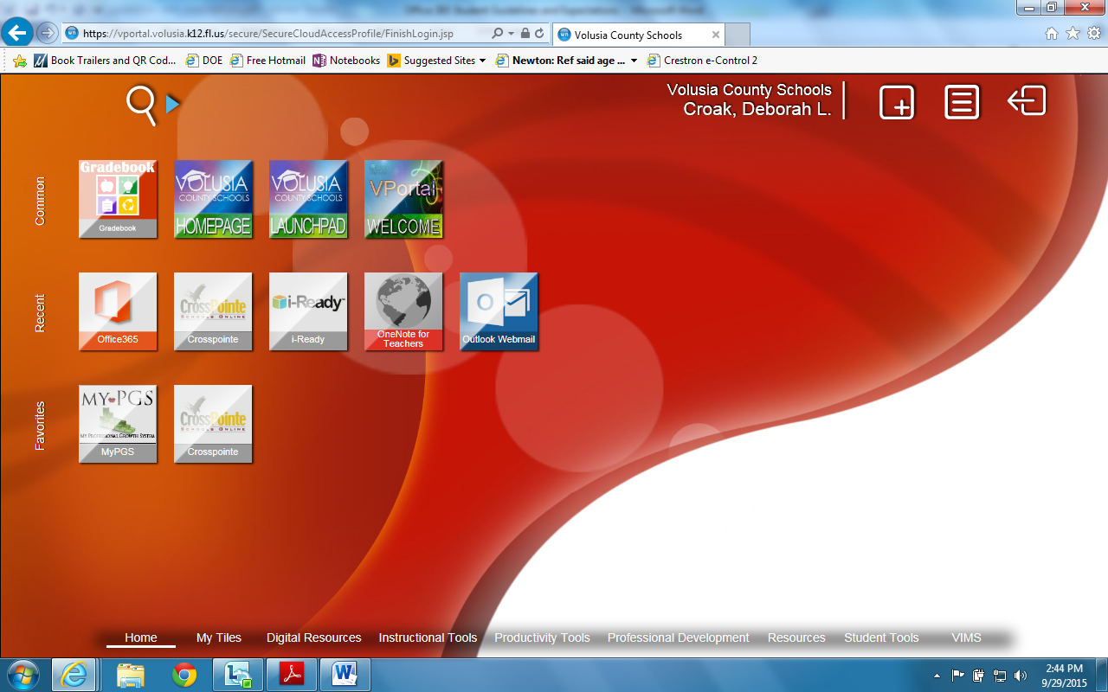

Once you login, you will see your Office 365 homepage.
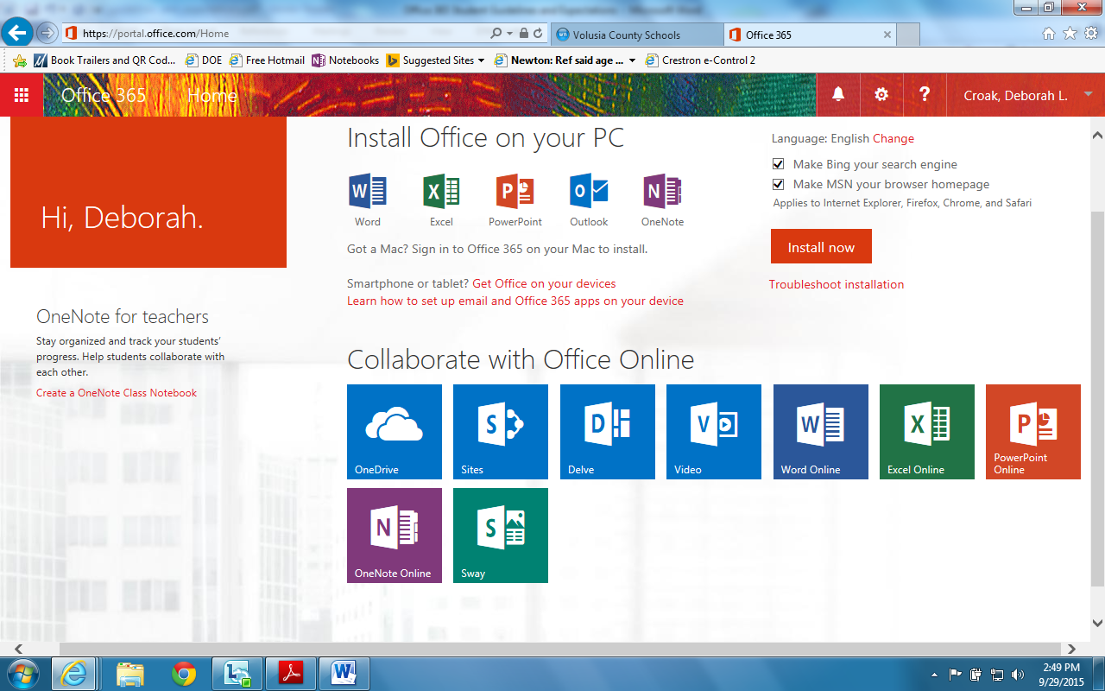

Simply click on OneDrive to create, save and share Office Documents. OneDrive can be saved as your home page. Go to settings and change your Office 365 settings.
Outlook: INTERNAL e-mail. Send or receive e-mail to your teachers or students who are also using Office365, their e-mails are automatically in the contacts. This allows you to easily share documents for collaboration or grading. It will not access outside e-mails or receive e-mails from outside the school district and is part of your public school record, so be aware of what you are sending and receiving.
Calendar: Use for important due dates!
People: Search for e-mail addresses.
Newsfeed: You can follow blogs and send PUBLIC, SCHOOL-RELATED comments to other students and teachers. This is similar to the newsfeed in Edmodo. Only use the Newsfeed if directed to by a teacher.
OneDrive: This is where you access your free storage and cloud versions of Word, PowerPoint and Excel. This would be a great place to type and store your work so that you always have access to it on any computer or device without using a flash drive (although it never hurts to back up your work in a second location when it is super important). Remember, you can also SHARE your documents and collaborate on the same document or PowerPoint with others via OneDrive.
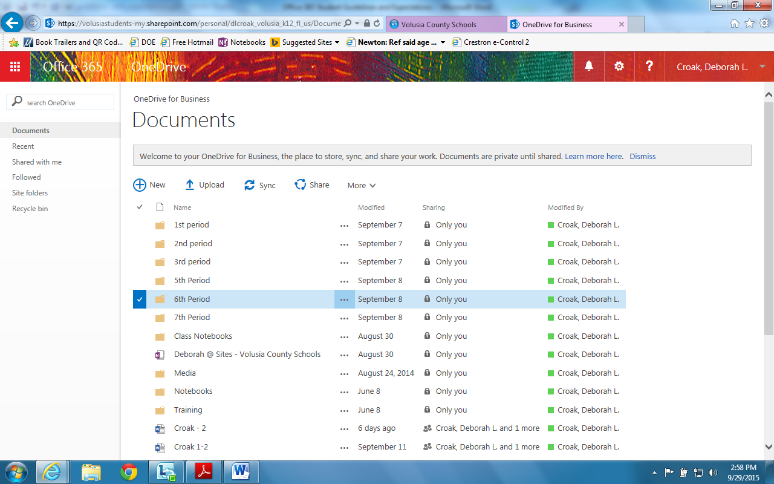

Sites: If you are following another student’s or teacher’s Office 365 site or blog, this is where you can
access it.
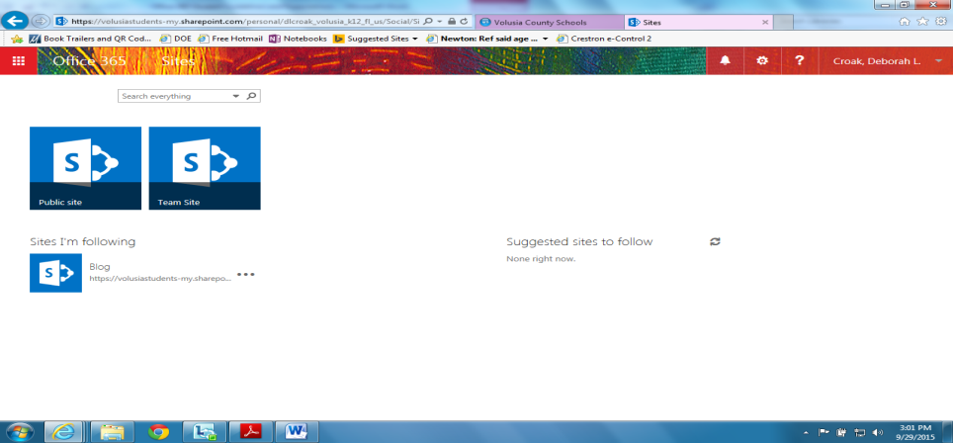

Blog: To access the blog that you may need to utilize for specific class assignments, click on the drop-down menu under your name, choose “About Me” and click on “blog” on the left side of the screen. Remember, this is not a personal social networking site. Your blog should be school appropriate and related to a class or assignment. If you have more than one blog assignment, be sure to set up categories for each assignment so that you can sort by category to see one assignment at a time.
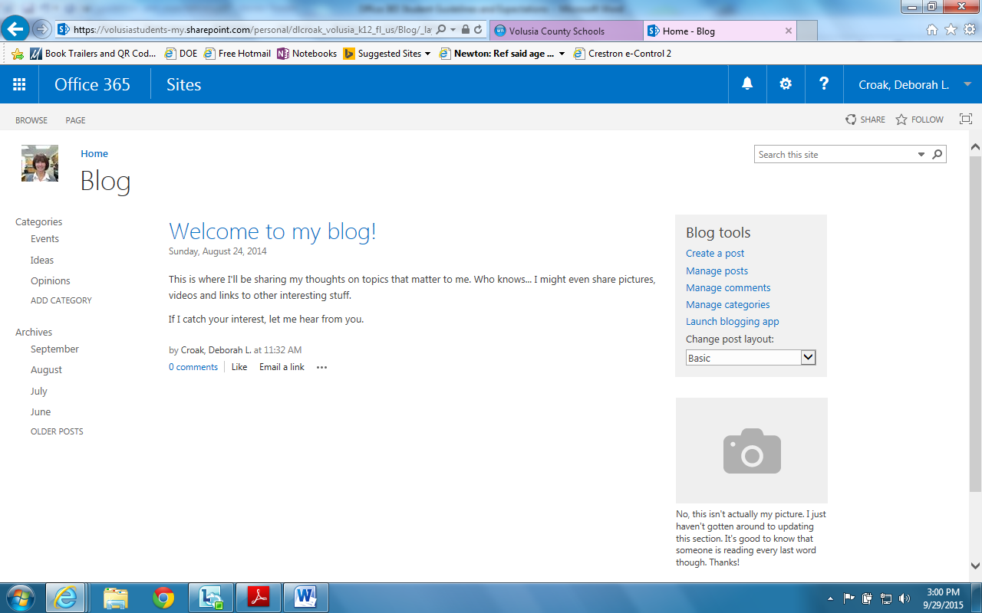

Sign up for your account today! If you have any problems, please come to the media center and see Mrs. Croak for help.

